# Edit Instructions

To modify the text content on the website:

1. Go to the Text Content section below.

2. Find the relevant webpage screenshot.

3. Identify the element in the screenshot, noting the number associated with it.

4. At the end of this document, locate the corresponding element in data.json using that number, and edit it as needed.

To modify links:

1. Go to the Link Section below.

2. Find the relevant webpage screenshot.

3. Identify the link element in the screenshot, noting the associated number.

4. At the end of this document, locate the corresponding link in data.json using that number, and edit it as needed.

For the “Contact Us” email setup:

1. Go to the Email Draft section below.

2. Follow a similar process: find the relevant element and make any necessary changes in the data.json file.

When users click the “Contact Us Now” button, the browser will open the mail app with an email draft. The user can then edit the draft and choose whether to send it.

# Text Content

Below is how to change text on the website

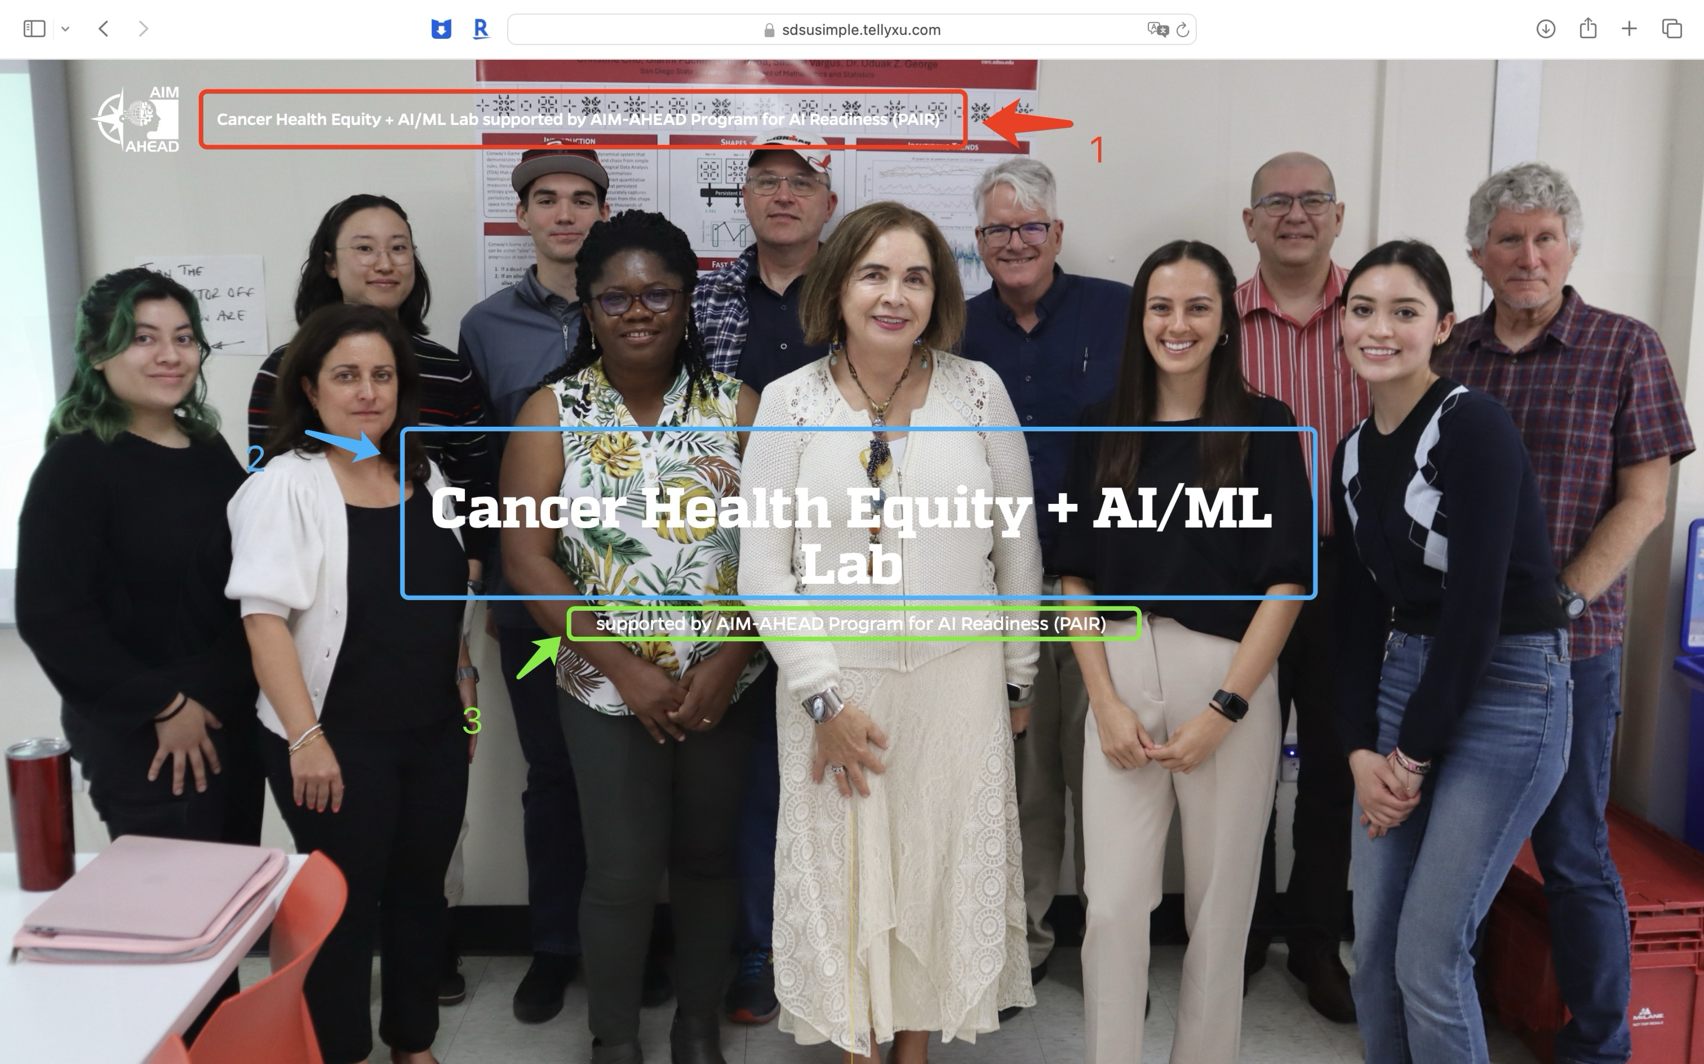

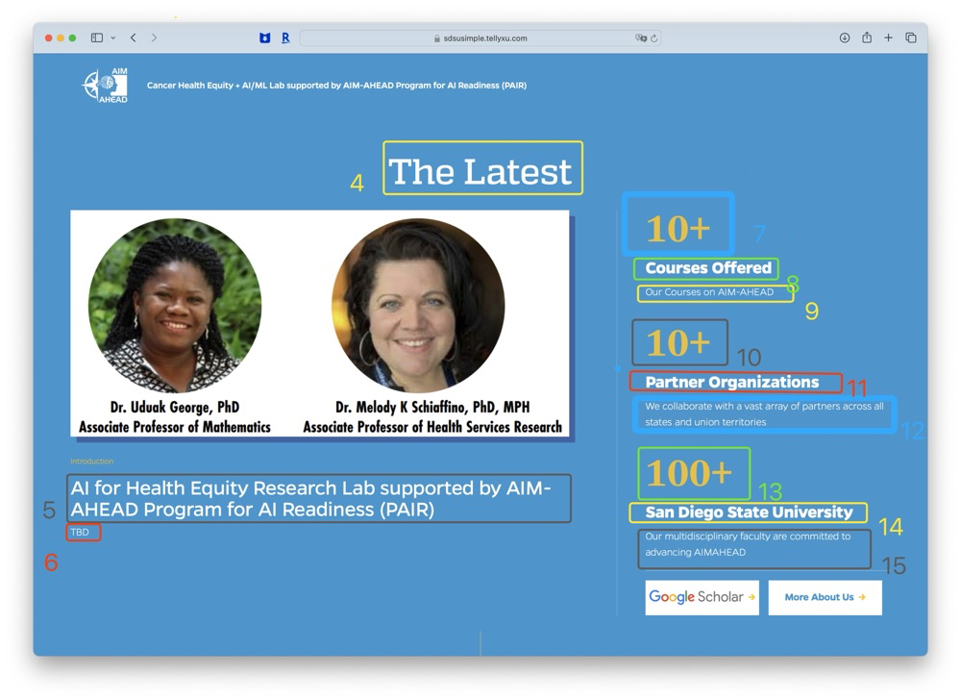

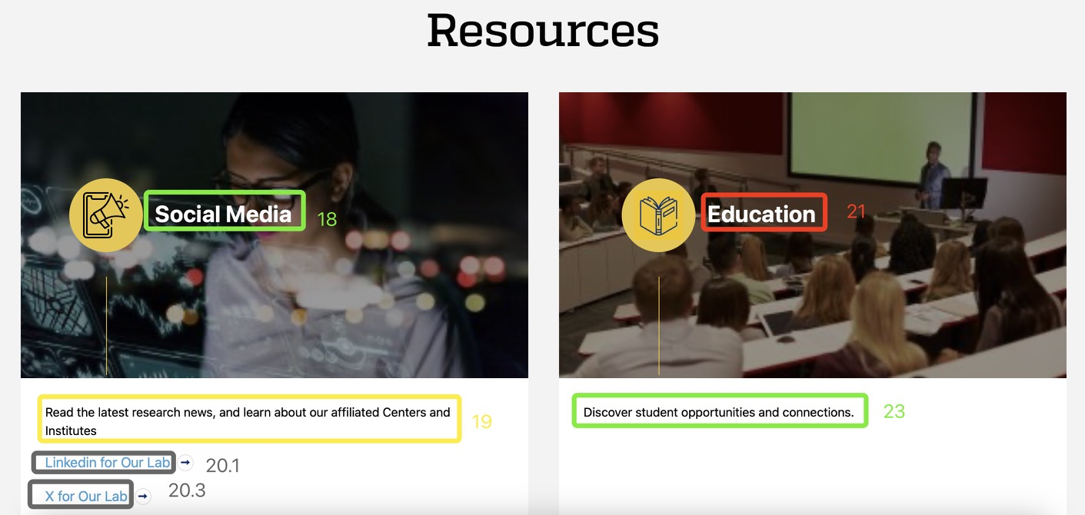



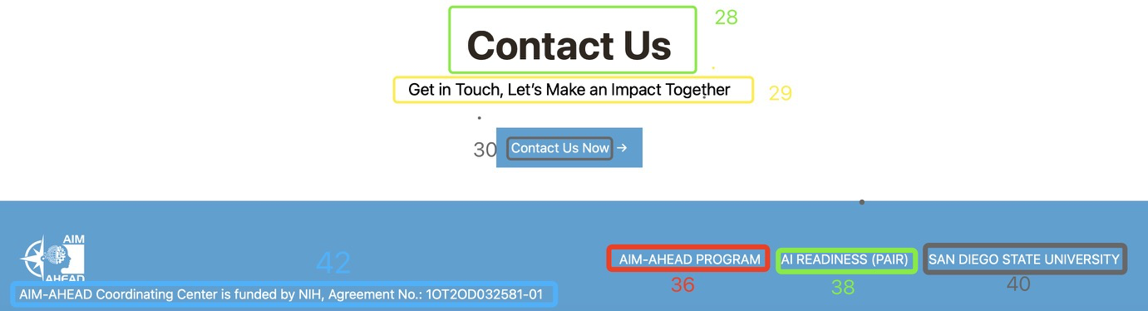

# Link

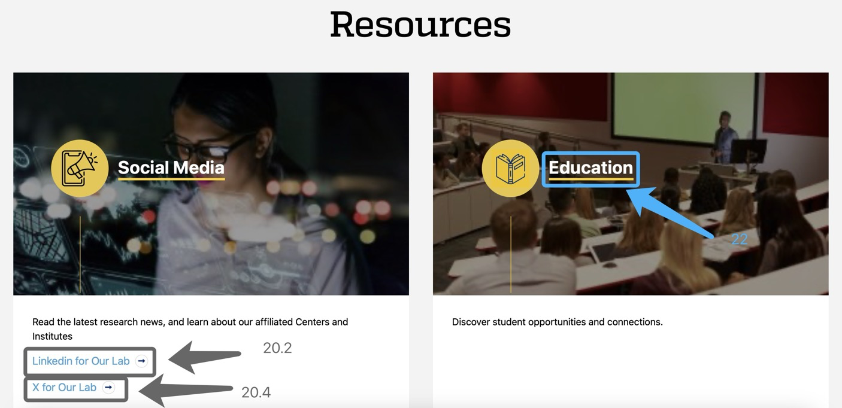



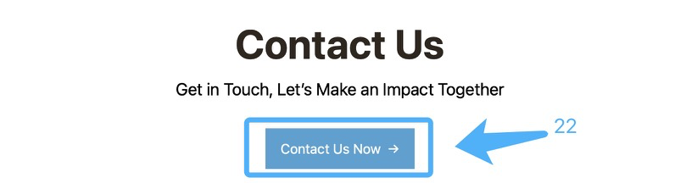



# Email Draft



When users click the “Contact Us Now” button, the browser will open the mail app with an email draft. The user can then edit the draft and choose whether to send it.

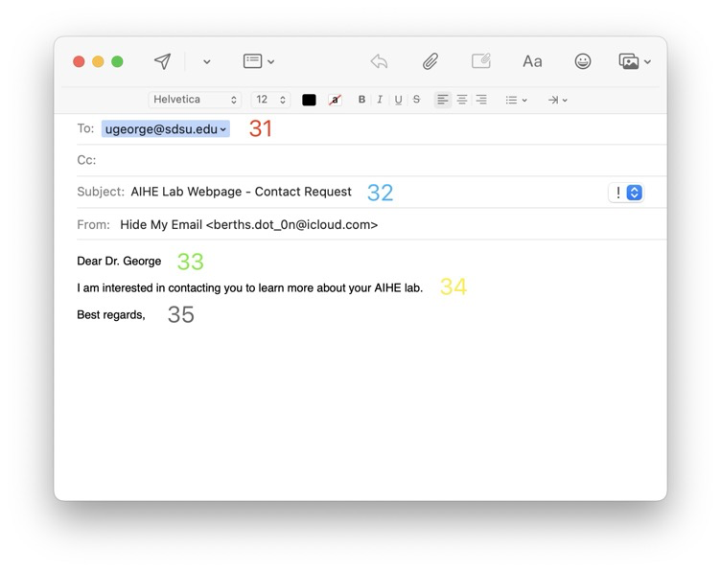

# data.json

The data.json file is located at the end of this document. Use the numbers from the screenshots to find and edit the specific elements for text, links, or email templates.



